# Assignment 4 : introduction to sora

### Sora is an advanced AI model developed by OpenAI that can generate high-quality, realistic videos from simple text descriptions. It represents a significant breakthrough in the field of generative AI by combining deep understanding of language with sophisticated visual generation. As a **text-to-video** model, Sora allows users to input natural language prompts, which the model then transforms into short video clips, often with rich detail, coherent motion, and visually stunning scenes.

### What sets Sora apart is its ability to simulate real-world physics, camera movements, and interactions between objects and environments—all from a single textual input. For example, a user might enter: “A dog playing fetch on the beach at sunset,” and Sora can generate a corresponding video clip that visually reflects the prompt with remarkable accuracy and realism. This capability is made possible by training on a large dataset of video and image-text pairs, allowing Sora to learn spatial, temporal, and semantic relationships. Sora can generate videos that are up to **one minute long**, with smooth motion, consistent character behavior, and detailed environments. It is built using a **diffusion transformer architecture**, which allows it to maintain both global coherence (e.g., maintaining a character’s identity throughout the clip) and fine-grained visual quality.Sora also serves as a foundational model that could eventually support a wide range of applications, from **film pre-visualization and video game design** to **education, simulation, marketing, and accessibility tools**. Artists and designers can use Sora to prototype creative ideas quickly, while educators could produce illustrative videos without the need for cameras or editing software.

### Despite its promise, OpenAI has emphasized that Sora is still being tested and refined. There are **challenges** to address, including ensuring factual accuracy, avoiding the spread of misinformation, preventing harmful or biased content, and improving physical consistency in generated scenes. To address these, OpenAI is working with red-teamers, domain experts, and policy advisors before making Sora widely available to the public.

### In summary, Sora is OpenAI’s pioneering step toward making video creation as simple as writing a sentence. With ongoing improvements and responsible deployment, Sora could transform how humans generate and consume visual media in the future

#### 

## 1. Comparison: Sora vs. DALL·E vs. Pika Labs vs. RunwayML

| Feature | Sora (OpenAI) | DALL·E (OpenAI) | Pika Labs | RunwayML (Gen-2) |
| --- | --- | --- | --- | --- |
| Media Type | Video (text-to-video) | Image (text-to-image) | Video (text-to-video) | Video (text-to-video) |
| Input Type | Text prompt, with possible image input | Text prompt, image editing inpaint | Text or image prompts | Text prompt, image/video input |
| Output Length | Up to 1 minute (high realism) | Single static images | Short clips (typically ~4–8s) | Short clips (4–16s, extendable) |
| Quality | Very high realism, physics-consistent | High-quality, stylized or realistic | Stylized, cinematic, sometimes anime | High realism, cinematic feel |
| Interactivity | Limited (not yet public) | Inpainting, image editing | Motion control, style adjustment | Motion brush, inpainting, keyframes |
| Use Cases | Films, simulations, ads, storytelling | Art, mockups, concept generation | Short-form content, social media | Filmmaking, design, storytelling |
| Accessibility | Not publicly available yet (as of 2025) | Publicly available | Waitlist or invite only | Freemium; paid for HD output |
| Notable Strengths | Real-world physics, coherence over time | High-quality stills, inpainting | Fast generation, community driven | Advanced timeline editing, AI tools |

#### 

## 2. Ethical Considerations in AI Video Generation

| Concern | Description | Risks |
| --- | --- | --- |
| Misinformation / Deepfakes | AI-generated videos can be used to create realistic fake news or impersonations | Erosion of public trust, political manipulation, fake evidence |
| Copyright Infringement | Models trained on copyrighted material may replicate or remix it in outputs | Legal risks, exploitation of artists' work without compensation |
| Consent & Privacy | Generating likenesses of real people without permission | Violates personal rights, reputational damage |
| Bias & Representation | Model biases may reflect stereotypes or exclude marginalized groups | Reinforces societal biases, lack of diversity in generated media |
| Misuse in Harmful Content | AI can automate creation of violent, sexual, or hate-inducing videos | Platforms must moderate and restrict malicious uses |
| Authenticity & Attribution | Difficulty distinguishing AI vs. real content | Need for watermarking, disclosure, and traceability of AI content |
| Environmental Impact | Video models require large compute resources | High carbon footprint from training and inference |

#### 

Task 2: Prompt Engineering Practice

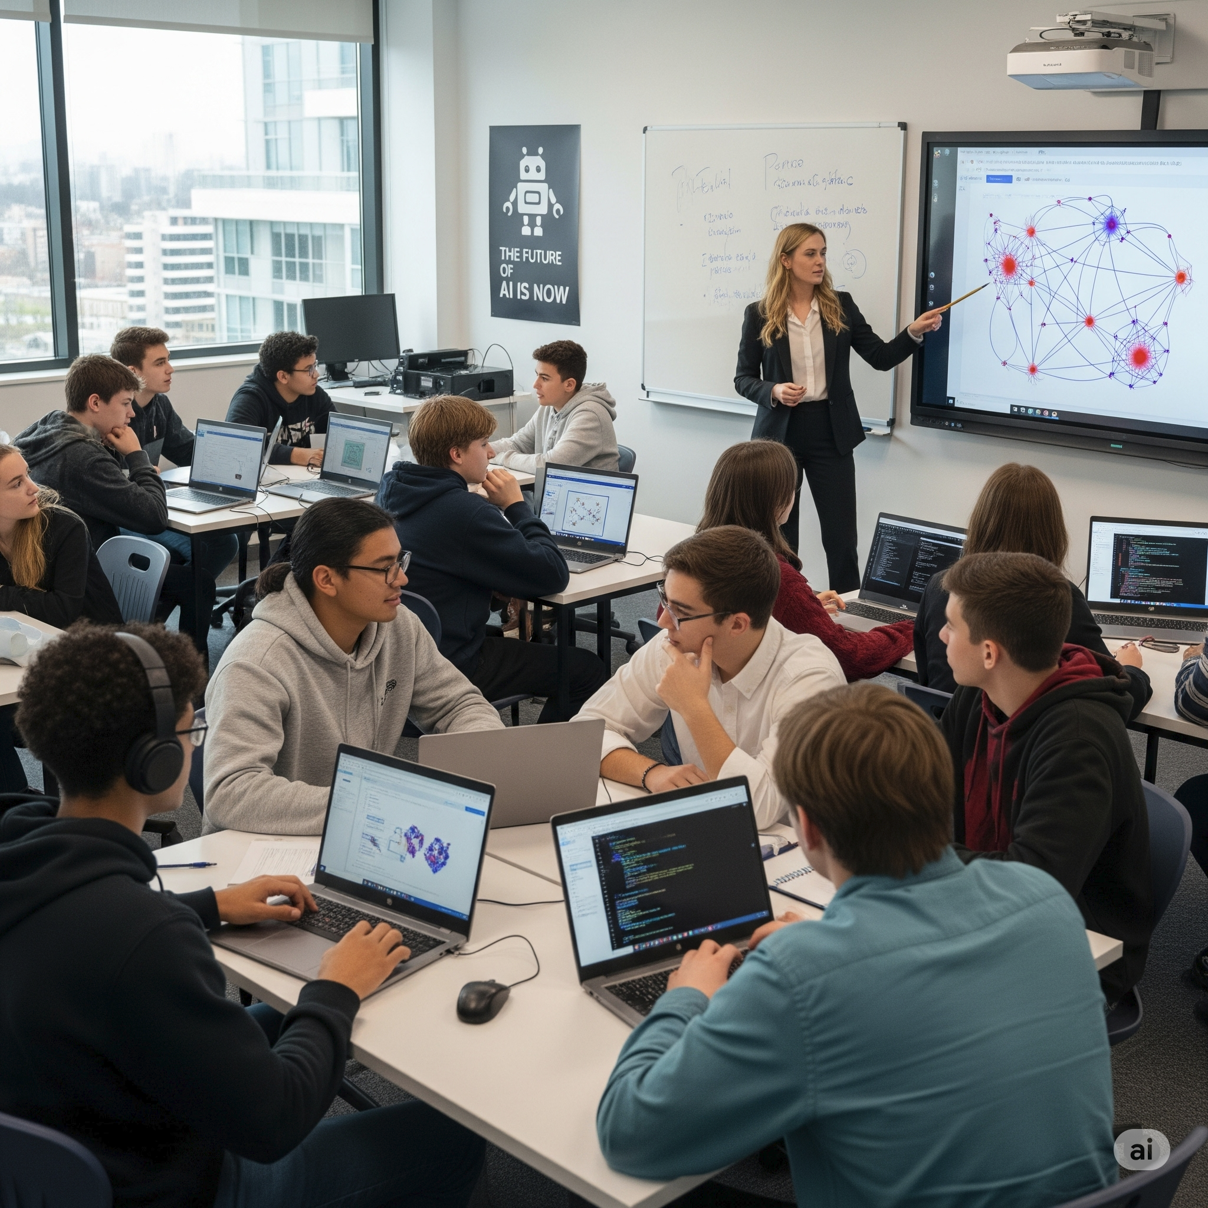

## Task 3: AI + Creativity Simulation

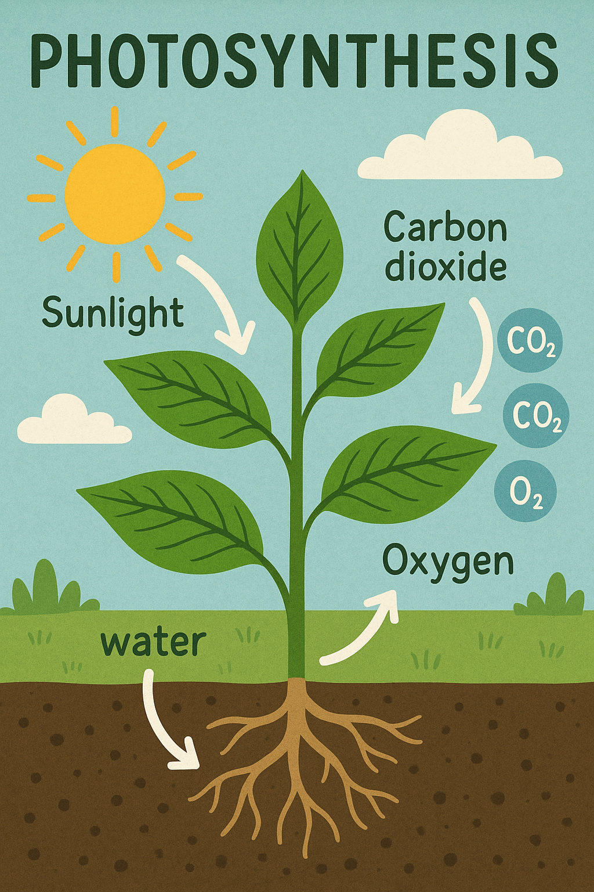

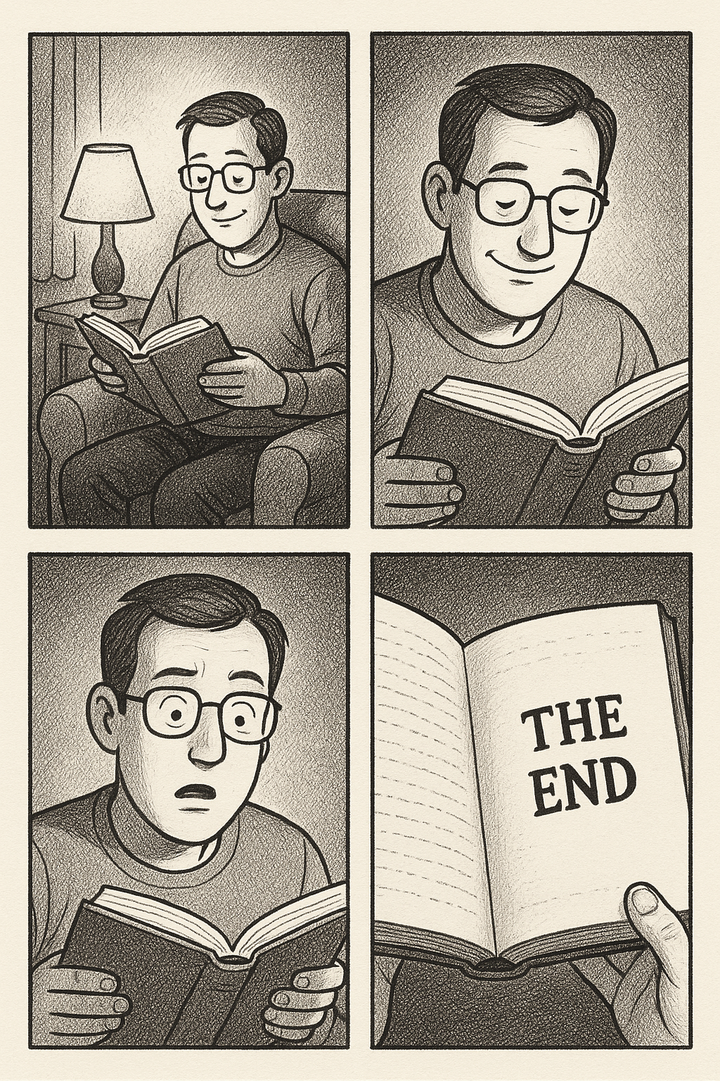

4 :Practice Activity (Without Direct SORA Access)